**1) Create web pages using Basic HTML Tags, Table, List, Image, and Frame Tags.**

**Main.html**

<!DOCTYPE html>

<html>

<head>

<title>EXP1</title>

</head>

<body>

<center ><h1>

<a href="basictags.html">Basic HTML</a><br/>

</center></h1>

<h3><a href="Tags.html">Tags</a><br/></h3>

<h3><a href="list.html">Lists</a><br/></h3>

<h3><a href="tables.html">Tables</a><br/></h3>

<h3><a href="image.html">Images</a><br/></h3>

<h3><a href="frames.html">Frames</a><br/></h3>

</body>

</html>

**OUTPUT:**

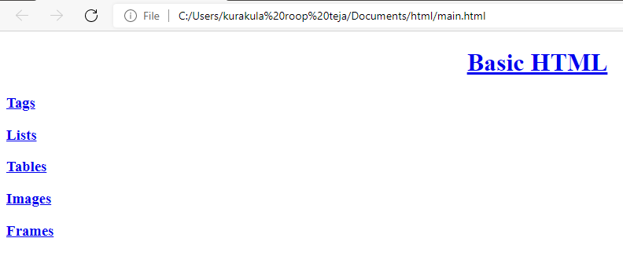

**Tags.html**

<!DOCTYPE html>

<html>

<head>

<title>basic</title>

</head>

<body>

<h1 align="center">HEADING TAGS</h1>

<pre>

<h3><B>H1,H2,H3,H4,H5,H6</B></h3>

</pre>

<h1 align="center">LIST TAGS</h1>

<b><pre><h3>

TWO TYPES

----> LIST

----> UNORDERED LIST

----> ORDERED LIST

</pre></b></h3>

<h1 align="center">EDITING TAGS</h1>

<pre><h3>

<B>---> ITALIC </B>

<B>---> BOLD </B>

<B>---> EM </B>

<B>---> STRONG </B>

<B>---> SMALL </B>

<B>---> BIG </B>

</pre></h3>

<button><a href="Main.html">return</a></button>

</body>

</html>

**OUTPUT:**

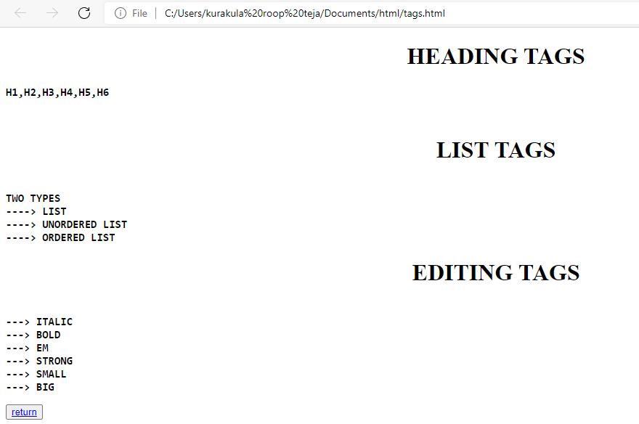

**List.html**

<!DOCTYPE html>

<html>

<head>

<title>Lists</title>

</head>

<body>

<h1>Unordered list</h1>

<ul type="square"><h2>Tea</h2>

<b>

<li>WebTechnologies</li>

<li>ComputerNetwork</li>

<li>DMDW</li>

</b>

</ul>

<h1>Ordered list</h1>

<b>

<li>ArtificialIntelligence</li>

<li>RedHat</li>

<li>MEANSTACK</li>

</b>

</ol>

<h1>Definition list</h1>

<dl>

<dt>WT</dt>

<dd>Web Technologies</dd>

<dt>HTML</dt>

<dd>HyperTextMarkupLanguage</dd>

</dl>

<h1>Miscallenous list</h1>

<ul>

<li><h3>SUB</h3>

<ol>

<li>HCI</li>

<li>ECom</li>

<li>ComputerNetworks</li>

</ol>

</li>

<li><h3>LABS</h3>

<ol>

<li>C</li>

<li>CPP</li>

<li>JAVA</li>

</ol>

</li>

<li><h3>LABS01</h3>

<ol>

<li>WT Lab</li>

<li>CN Lab</li>

<li>DMDW Lab</li>

</ol>

</li>

</ul>

<button><a href=" Main.html">return</a></button>

</body>

</html>

**OUTPUT:**

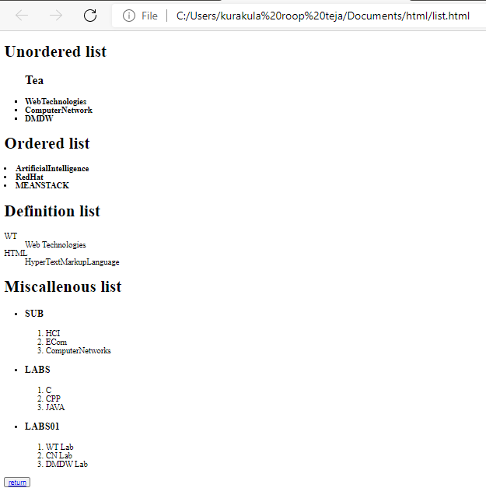

**Tables.html**

<!DOCTYPE html>

<html>

<head>

<title>tables</title>

<style type="text/css">

td{

border: 0px;

text-align: center;

}

tr{

text-align: center;

}

</style>

</head>

<body>

<center>

<h1>TIME TABLE</h1>

</center>

<table border="0 px" align="center">

<tr>

<th>Day</th>

<th>9:30 - 10:20</th>

<th>10:20 - 11:10</th>

<th>11:00 - 12:00</th>

<th>12:00 - 12:50</th>

</tr>

<tr>

<td>MONDAY</td>

<td>DMDW</td>

<td>WT</td>

<td>E.COM</td>

<td>HCI</td>

</tr>

<tr>

<td>TUESDAY</td>

<td>CN</td>

<td>WT</td>

<td>E.COM</td>

<td>HCI</td>

</tr>

<tr>

<td>WEDNESDAY</td>

<td>DMDW</td>

<td>WT</td>

<td>E.COM</td>

<td>CN</td>

</tr>

<tr>

<td>THURSDAY</td>

<td>DMDW</td>

<td>WT</td>

<td>E.COM</td>

<td>HCI</td>

</tr>

<tr>

<td>FRIDAY</td>

<td>DMDW</td>

<td>WT</td>

<td>E.COM</td>

<td>HCI</td>

</tr>

<tr>

<td>SATURDAY</td>

<td>DMDW</td>

<td>WT</td>

<td>E.COM</td>

<td>HCI</td>

</tr>

</table>

<button><a href=" Main.html">return</a></button>

</body>

</html>

**OUTPUT:**

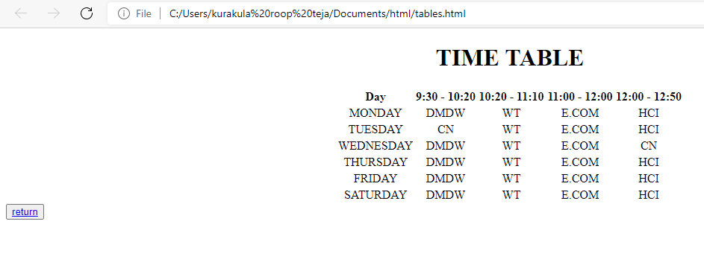

**Image.html**

<!DOCTYPE html>

<html>

<head>

<title>Images</title>

</head>

<body>

<div style="height: 315px;width:100%">

<img src="colorpic.jpg" height="300px" width="50%" align="center">

</div>

<button><a href=" Main.html">return</a></button>

</body>

</html>

**OUTPUT:**

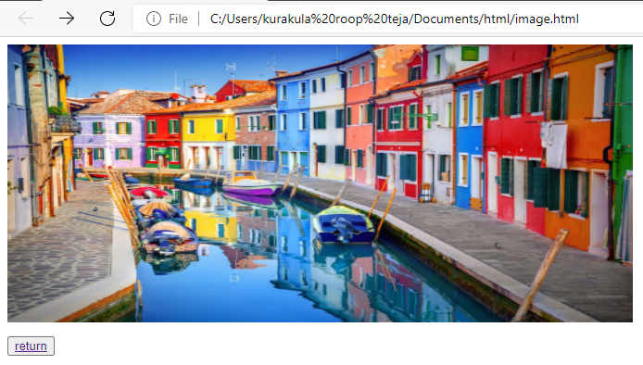

**Frames.html**

<!DOCTYPE html>

<html>

<head>

<title>Frame tags</title>

</head>

<frameset cols="40%,40%" rows="40%,40%">

<frame src="Tags.html">

<frame src="LIST.html">

<frame src="TABLES.html">

<frame src="Image.html">

</frameset>

</html>

**Output:**

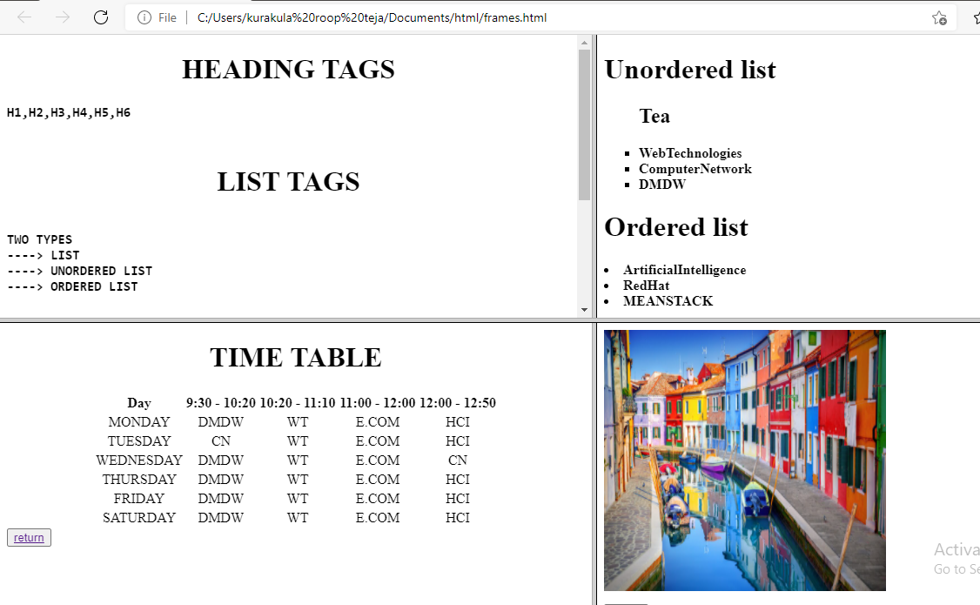

**2)Using Form Tags**

**2.1) Create a Login Form**

<html>

<head>

<title>Working with Forms</title>

</head>

<body>

<center>

<h1>Login Form</h1>

<table>

<tr>

<td><label for="username">User Name</label></td>

<td><input type="text" id="un" name="un" value="Enter User Name" /></td>

</tr>

<tr>

<td><label for="password">Password</label></td>

<td><input type="password" id="pwd" name="pwd" value="Enter Password" /></td>

</tr>

<tr>

<td><input type="submit" value="Click to login" /></td>

<td><input type="reset" value="Click to Reset" /></td>

</tr>

</table>

</center>

</body>

</html>

**Output:**



**2.2). Create a “registration form” with the following fields**

**a) Name (Text field)**

**b) Password (password field)**

**c) E-mail id (text field)**

**d) Phone number (text field)**

**e) Sex (radio button)**

**f) Date of birth (3 select boxes)**

**g) Languages known (check boxes – English, Telugu, Hindi, Tamil)**

**h) Address (text area)**

<html>

<head>

<title>working with forms</title>

</head>

<body>

<center>

<h1>Registration Form</h1>

<form>

<table>

<tr>

<td><label for="User Name">User Name</label></td>

<td><input type="type" id="un" name="un" value="Enter User Name" />

</tr>

<tr>

<td><label for="password">Password</label></td>

<td><input type="password" id="pwd" name="pwd" value="Enter password" />

</tr>

<tr>

<td><label for="E-mail">E-mail id</label></td>

<td><input type="text" id="un" name="un" value="New e-mail id" /></td>

</tr>

<tr>

<td><label for="Phone no">Phone number</label></td>

<td><input type="text" id="un" name="un" value="phone number" /></td>

</tr>

<tr>

<td><label for="Gender">Gender</label></td>

<td>

<input type="radio" id="pc" name="pc" value="Male" />Male

<input type="radio" id="pc" name="pc" value="Female" />Female

</td>

</tr>

<tr>

<td><label for="date">DOB</label></td>

<td><input type="date" name="date" id="date" required="on" placeholder=" "></td>

</tr>

<tr>

<td><label for="languages">Languages known</label></td>

<td>

<input type="checkbox" id="pc" name="pc" value="English" />English,<br/>

<input type="checkbox" id="pv" name="pv" value="Telugu" />Telugu<br/>

<input type="checkbox" id="pc" name="pc" value="Hindi" />Hindi<br/>

<input type="checkbox" id="pv" name="pv" value="Tamil" />Tamil<br/>

</td>

</tr>

<tr>

<td><label for="address">Address</label></td>

<td>

<textarea rows="5" cols="20">Type your Address here</textarea>

</td>

</tr>

<tr>

<td><input type="submit" values="Click to submit" /></td>

<td><input type="reset" values="Click to reset" /></td>

</tr>

</center>

</body>

</html>

**OUTPUT:**

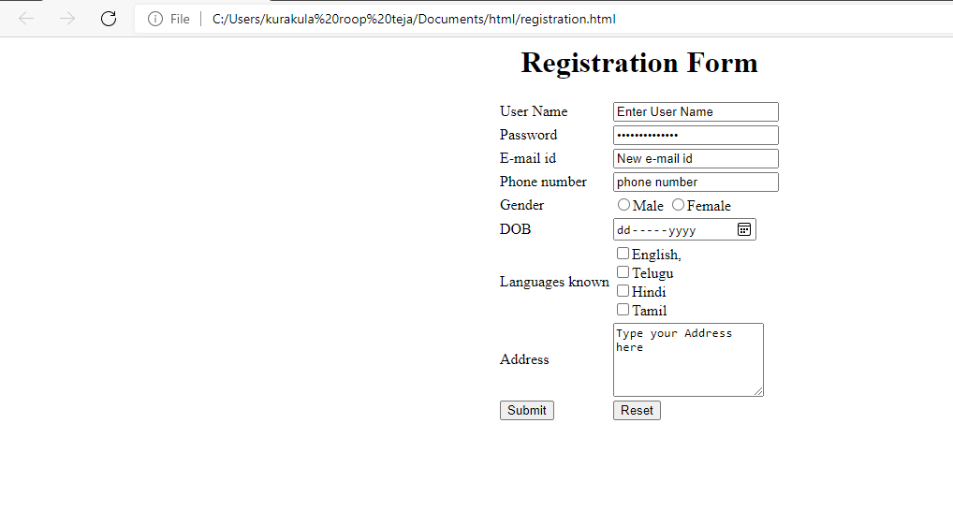

**3) CSS & Java Script**

**3.1) Design a web page using CSS (Cascading Style Sheets) which includes the following:**

**3.1.1) Use different font, styles: In the style definition you define how each selector should work (font, color etc). Then, in the body of your pages, you refer to these selectors to activate the styles.**

**Style.css**

**3.1.1.html**

<html>

<head>

<title>Usage of different font,styles and colors </title>

<link rel="stylesheet" type="text/css" href="3.1.1.css"/>

</head>

<body>

<h1>Aditya Engineering College</h1>

<h2>This is the header</h2>

<p>This is just text message</p>

</body>

</html>

**3.1.1.css**

h1

{

color:blue;

font-family:caStellar; font-size:22pt;

text-decoration:underline;

}

h2

{

color:orange;

font-family:Chiller; font-size:18pt;

text-decoration:overline;

}

P

{

color:magenta;

font-family:Trebuchet MS; font-size:14pt;

font-style:italic;

}

**Output:**

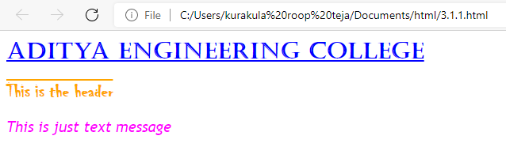

**3.1.2) Set a background image for the web page and control the repetition of the image with the background-repeat property.**

**3.1.2.html**

<html>

<head>

<title>Controlling background image</title>

<style type="text/css">

body

{

background-image:url("Hopetoun_falls.jpg");

background-repeat:no-repeat

}

</style>

</head>

<body text="#fe78a2">

<h1>**Hopetoun_falls**</h1>

</body>

</html>

**Output:**

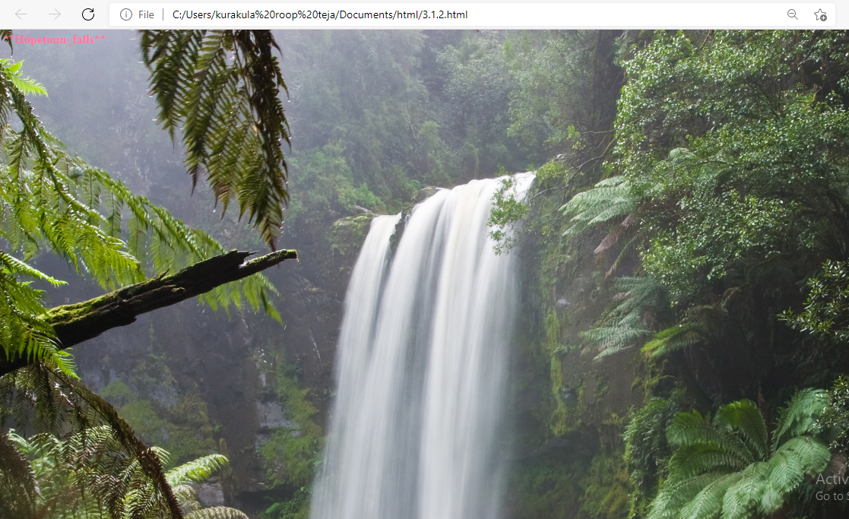

**3.1.3) Define styles for link as visited, active, hover & link**.

**3.1.3.html**

<html>

<head> <h1 align=center> Web Page using CSS </h1>

<style type="text/css">

body{background-image:url(colorpic.jpg); background-repeat:repeat-y;}

p{color:blue;font-size:20pt;font-family:chiller;background-image:url(img1.jpg);}

a:link{font-size:20pt;background-color:white;}

a:hover{font-size:20pt;background-color:yellow;cursor:crosshair;}

a:active{font-size:20pt;background-color:cyan;cursor:help;}

a:visited

{

font-size:20pt;background-color:blink;

}

</style>

</head>

<title> CSS Webpage!!! </title>

<body>

<br>

<p> Weclome to Web page using CSS where CSS means Cascading Style Sheets! using CSS we can apply the common styles to different tags and also different

styles to same tag i.e. repeated more than once in the html file </p>

<a href="form(registration).html"><center> Register </center></a>

<br><br><br><br><br><br><br><br><br>

</body>

</html>

**Output:**

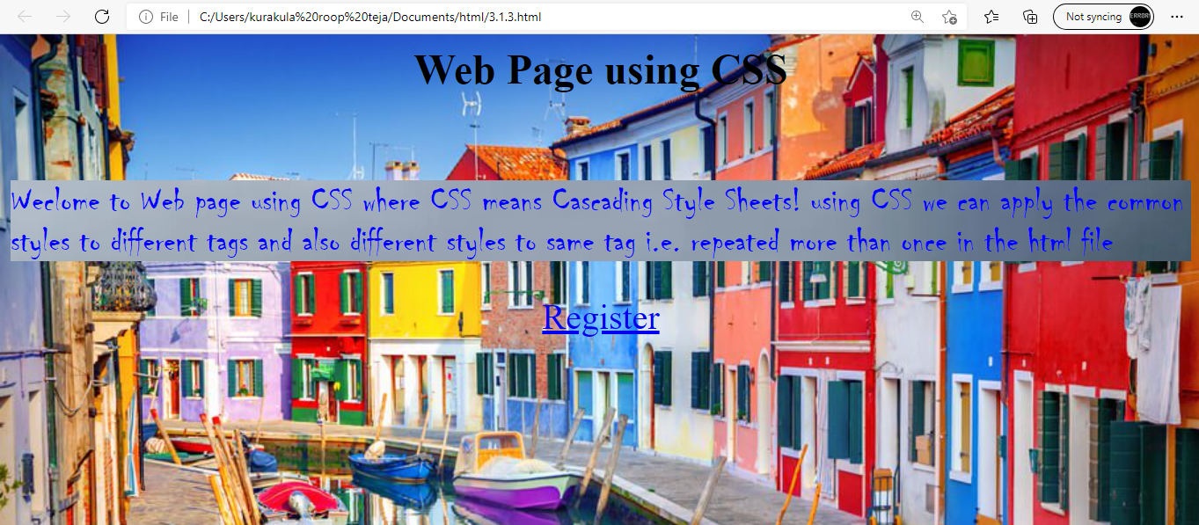

**3.2) Write a JavaScript that takes a number from one text field in the range of 0-999 and display it in other text field in words. If the number is out of range, it should show “out of range” and if it is not a number, it should show “not a number” message in the result box.**

**3.2.html**

<!DOCTYPE html>

<html>

<head>

<meta charset="utf-8">

<title></title>

<script language="javascript">

function convert_number_to_words(number)

{

hyphen='-';

conjunction='and';

separator='.';

dictionary={0:'zero',1:'one',2:'two',3:'three',4:'four',5:'five',6:'six',7:'seven',8:'eight',

9:'nine',10:'ten',11:'eleven',12:'twelve',13:'thirteen',14:'fourteen',15:'fifteen',16:'sixteen',

17:'seventeen',18:'eighteen',19:'nineteen',20:'twenty',30:'thirty',40:'fourty',50:'fifty',

60:'sixty',70:'seventy',80:'eighty',90:'ninety',100:'hundred',};

if(number<0 || number>999)

{

alert("enter a number range between 0 and 999");

return "";

}

switch(true)

{

case(number<21):

string=dictionary[number];

break;

case(number<100):

tens=parseInt(number/10)*10;

units=number%10;

string=dictionary[tens];

if(units){

string+=hyphen+dictionary[units];

}

break;

case(number<1000):

hundreds=parseInt(number/100);

remainder=number%100;

string=dictionary[hundreds]+ ' ' +dictionary[100];

if(remainder){

string+=conjunction+convert_number_to_words(remainder);

}

break;

default:

break;

}

return string;

}a=prompt("Enter a number");

num=parseInt(a);

document.write(convert_number_to_words(num));

</script>

</head>

<body>

<h2 align="center"><i>WELCOME TO JAVASCRIPT</i></h1>

</body>

</html>

**Output.1:**

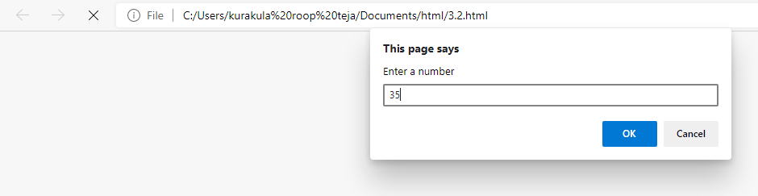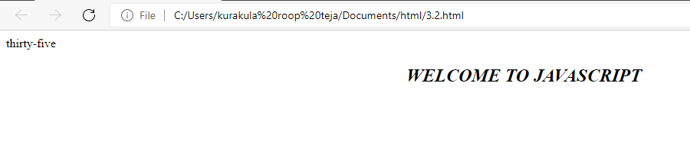

**4) Java Script & XML**

**4.1) Write a JavaScript to validate the following fields in a registration page created in week 2**

**a. Name (start with alphabet and followed by alphanumeric and the length should not be less than 6 characters)**

**b. Password (it allows alphanumeric, special symbols and should not be less than 6 characters)**

**c. E-mail (should not contain invalid email addresses)**

**4.1.html**

<html>

<head> <h1 align=center>Welcome to Validation Checking</h1><hr width=50%>

<script language="javascript">

function validation()

{

var x=f.un.value; var len=x.length; var val=x.charCodeAt(0); var p=f.pw.value; var c=f.cpw.value; var a=f.email.value; var atpos=a.indexOf("@"); var dotpos=a.lastIndexOf("."); if(len<6 || x=='' || x==null)

{

alert("check your username! must be minimum 6 characters"); if(val<65 || val>90 && val <97 || val>122) alert("username must begin with an alphabet"); return false;

}

else if(val<65 || val>90 && val <97 || val>122)

{

alert("username must begin with an alphabet"); return false;

}

else if(p=='' || c=='' || p.length<6 || c.length<6 || p!=c)

{

alert("Password and Confirm Password should be same and greater than 6 characters!"); return false;

}

else if(atpos<6 || dotpos<atpos+6 || dotpos+2>=a.length)

{

alert("Not a valid email id"); return false;

}

else

alert("Congragulations! you have submited successfully");

}

</script>

</head>

<title> Validation Check! </title>

<body>

<table align=center>

<form name="f" action="success.html" onsubmit="return validation();" method="post">

<tr><td>User Name:</td><td><input type="text" name="un"/></td></tr>

<tr><td>Password:</td><td><input type="password" name="pw"/></td></tr>

<tr><td>Confirm Password:</td><td><input type="password" name="cpw"/></td></tr>

<tr><td>E-mail ID:</td><td><input type="text" name="email"/></td></tr>

<tr><td></td><td><input type="submit" value="Submit"/></td></tr>

</form></table>

</body>

</html>

**Output:**

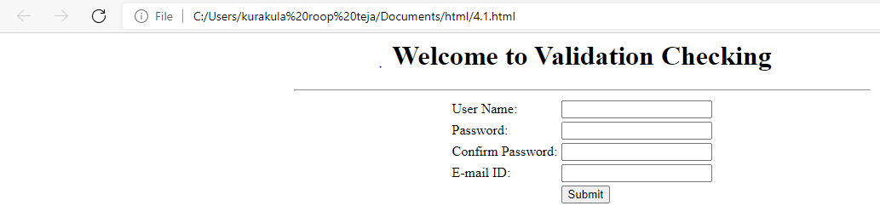

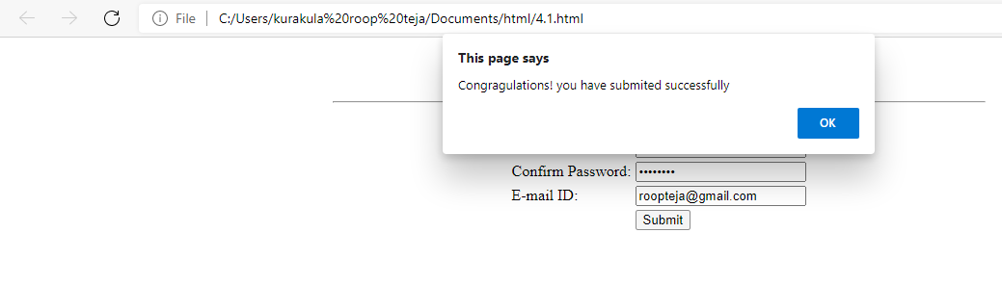

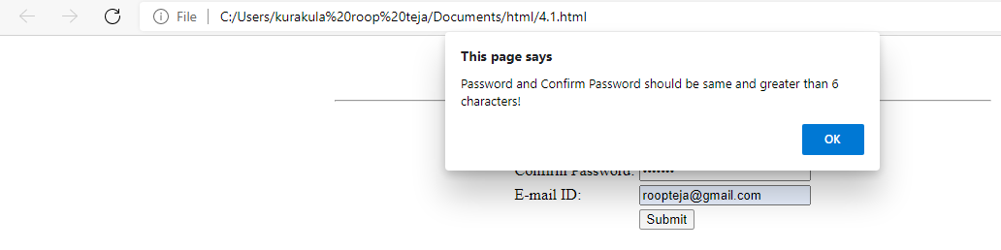

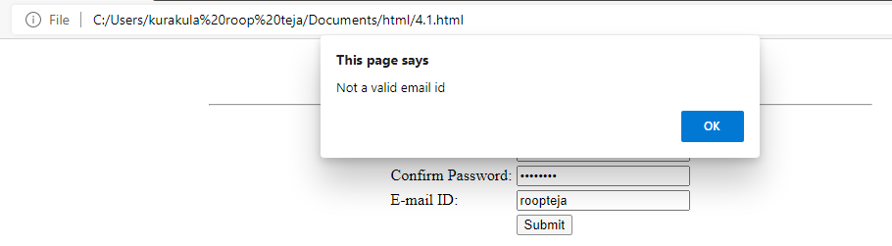

**4.2) Write an XML file which will display the Book information which includes the following: a) Title of the book ;b) Author Name ;c) ISBN number ;d) Publisher name e) Edition ;f) Price Write a Document Type Definition (DTD) to validate the above XML file and display the details in a table (to do this use XSL).**

**4.2.dtd**

<!ELEMENT bookdetails(books+)>

<!ELEMENT books(title,author,isbn,publisher,edition,price)>

<!ELEMENT title(#PCDATA)>

<!ELEMENT author(#PCDATA)>

<!ELEMENT isbn(#PCDATA)>

<!ELEMENT publisher(#PCDATA)>

<!ELEMENT edition(#PCDATA)>

<!ELEMENT price(#PCDATA)>

**4.2.xml**

<?xml version="1.0"?>

<!DOCTYPE bookdetails SYSTEM "4.2.dtd">

<?xml-stylesheet type="text/xsl" href="4.2.xsl"?>

<bookdetails>

<books>

<title>C</title>

<author>Balaguruswamy</author>

<isbn>123456</isbn>

<publisher>Oxford</publisher>

<edition>Edition-II</edition>

<price>$30.00</price>

</books>

<books>

<title>C++</title>

<author>yaswanth kanethkar</author>

<isbn>654321</isbn>

<publisher>Tata McHill</publisher>

<edition>Edition-I</edition>

<price>$35.00</price>

</books>

<books>

<title>JAVA</title>

<author>Herbert Schildt</author>

<isbn>789456</isbn>

<publisher>Cenage</publisher>

<edition>Edition-IV</edition>

<price>$50.00</price>

</books></bookdetails>

**4.2.xsl**

<?xml version="1.0"?>

<xsl:stylesheet version="2.0" xmlns:xsl="http://www.w3.org/1999/XSL/Transform">

<xsl:template match="/">

<html>

<head><center>Book Details</center></head>

<body>

<hr width="50%"/>

<table border="1" align="center">

<tr>

<th>TITLE</th>

<th>AUTHOR</th>

<th>ISBN</th>

<th>PUBLISHER</th>

<th>EDITION</th>

<th>PRICE</th>

</tr>

<xsl:for-each select="bookdetails/books">

<tr>

<td><xsl:value-of select="title"/></td>

<td><xsl:value-of select="author"/></td>

<td><xsl:value-of select="isbn"/></td>

<td><xsl:value-of select="publisher"/></td>

<td><xsl:value-of select="edition"/></td>

<td><xsl:value-of select="price"/></td>

</tr>

</xsl:for-each>

</table></body></html></xsl:template>

</xsl:stylesheet>

**Output:**

